|  |
| --- |
| Set 4O |
| Android Assignment |
| Comp 4985 |
|  |
| **Jordan Marling A00865429 Mateusz Siwoski A00758640** |
| **3/5/2014** |

|  |
| --- |
|  |

Table of Contents

Features: 3

Installation: 4

Use: 4

Design: 5

Pseudo code 6

Test Cases: 7

Figures: 8

Figure 1a: Start Application 8

Figure 2a: Menu System with image buttons 8

Figure 2b: Menu System with image buttons 9

Figure 2c: Menu System with image buttons 9

Figure 3a: Generate Google Maps 10

Figure 3b: Generate Google Maps 10

Figure 4a: Get Barometric Data 11

Figure 4b: Get Barometric Data 11

Figure 5: Text to Speech Feature 12

Figure 6a: Tracking Client on Map 12

Figure 6b: Tracking Client on Map 12

Figure 7a: Changing Map Type 13

Figure 7b: Changing Map Type 13

Figure 8: Display Address-Coordinates 13

Figure 8b: Display Address-Coordinates 14

Figure 9: Toast messages for TTS 14

Figure 10a: Take a picture with the front camera 14

Figure 10b: Take a picture with the front camera 15

Figure 10c: Take a picture with the front camera 15

Figure 10d: Take a picture with the front camera 15

Figure 11a: Send picture/Display on Google Maps 16

Figure 11b: Send picture/Display on Google Maps 16

# **Features:**

The following features are available in our application:

* Integration with the Google Maps API
* Barometric Readings
* Text-to-speech (Client joins/leaves and changes position)
* Enabled/disabled Text-To-Speech
* Toast messages for updates
* GPS Coordinates
* Multiple Clients connecting to server
* GPS Tracking on map (clients route is tracked)
* GUI Design
* Changing map type form Hybrid to Normal (vice versa)
* Continuous Map Updates
* Custom Usernames for clients (IP is set as default)
* Allow client to take a picture with the front camera and send it to the server

# **Installation:**

The following is the guideline to install the application. A file managing app will be necessary on the phone (Suggestions include Astro File Manager and App Installer):

1. Connect phone to computer
2. Open the android phone on the PC
3. Browse to a folder where you would like to install the .apk (suggested would be Download)
4. Copy the .apk to the folder
5. On the phone, open the file manager and browse to the location of the folder
6. Click on the app name
7. Click install
8. Click Done to finish installation or Open to open the app right away

Use:

Open the application on two phones. One phone will be the client, the other will be the server.

1. On the server, set the Port Number and either enable or disable Text-to-Speech. Click start to begin tracking the client. Stop will stop the client
2. On the client, set a username for the client. If the client does not set a username, default IP will be used.
3. Set the server’s IP address
4. Set the server’s Port number
5. Set the Location Provider option (Network or GPS)
6. Click Start to begin sending data to the Server

Design:

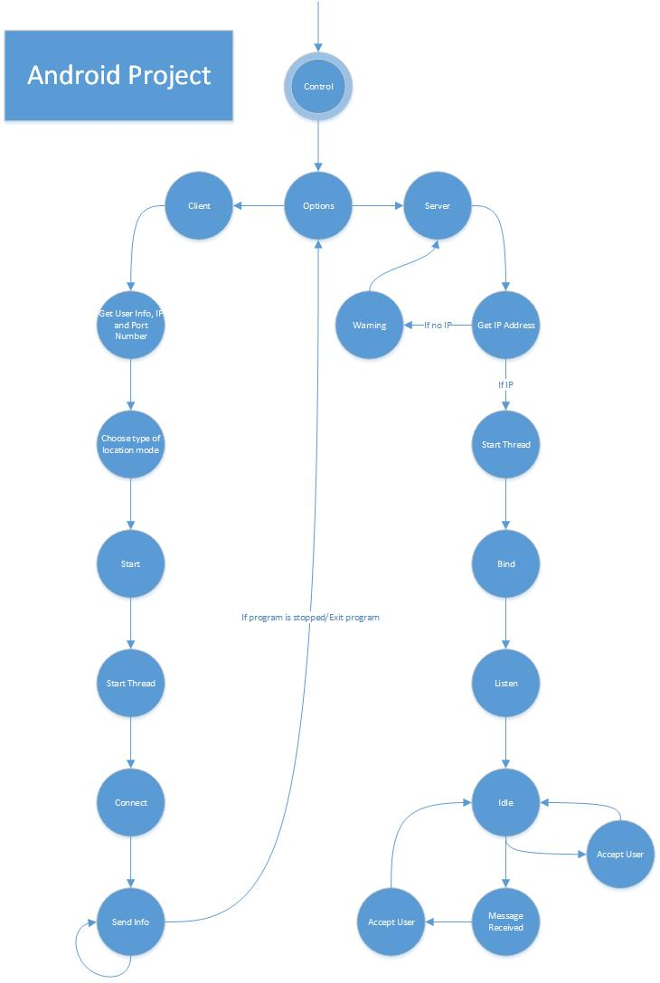

Pseudo code:

mainActivity{

press Client()

press Server()

}

Client{

Accept user input

Connects to the server in separate thread{

Send username information

Send the GPS/Barometer information

}

}

Server(){

Accept user input

If start pressed{

Create Google Map

Start Server Thread () {

Bind

Listen

Accept a Client

Get All Information from Client Thread ()

}

}

}

Get All Information from Client Thread(){

Get User Name

Loop(while client connected){

Get GPS/Barometer data

Update Google Maps

}

}

# Test Cases:

|  |  |  |  |  |  |  |  |  |
| --- | --- | --- | --- | --- | --- | --- | --- | --- |
|  |  |  |  |  |  |  |  |  |
| **Test** | **Tests Description** | | **Tools Used** | **Expected Result** | **Pass/Fail** | **Notes** | | |
| 1 | Start Application | | Assignment3/ Android Studio | Program should begin on the Android Device | Pass | See Figure 1 | | |
| 2 | Menu system with image buttons | | Assignment3/ Android Studio | Application should be able to move to different menu options | Pass | See Figure 2a/2b/2c | | |
| 3 | Generate Google Map | | Assignment3/ Android Studio | Map is generated to the default location in Burnaby | Pass | See Figure 3a/3b | | |
| 4 | Get Barometric Data | | Assignment3/ Android Studio | Get the pressure using the Android Barometer Sensor, Pop up as a Toast Message | Pass | See Figure 4a/4b | | |
| 5 | Text To Speech Feature | | Assignment3/ Android Studio | Set a priority and file path and display the contents of the file | Pass | See Figure 5 | | |
| 6 | Tracking Client | | Assignment3/ Android Studio | Tracking the client with routing | Pass | See Figure 6a/6b | | |
| 7 | Changing Map Type | | Assignment3/ Android Studio | Change map from Hybrid to Normal (vice versa) | Pass | See Figure 7a/7b | | |
| 8 | GPS Coordinates to Address | | Assignment3/ Android Studio | Get the GPS Coordinates/Translate to Address | Pass | See Figure 8a/8b | | |
| 9 | Toast messages replacing TTS | | Assignment3/ Android Studio | When TTS is disabled, toast messages will be displayed | Pass | See Figure 9 | | |
| 10 | Take a picture with the front Camera | | Assignment3/ Android Studio | Allow Client to take a picture with the front camera, display in view | Pass | See Figure 10a/10b/10c | | |
| 11 | Send Picture/Display on Google Maps | | Assignment3/ Android Studio | The picture will be received by the Server and displayed | Pass | See Figure 11a/11b | | |

# Figures:

## Figure 1a: Start Application

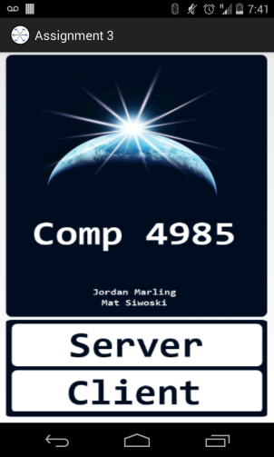

## Figure 2a: Menu System with image buttons

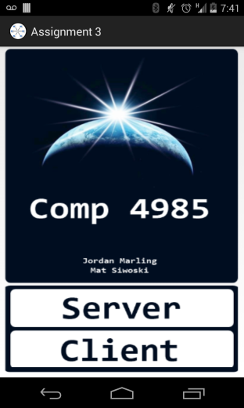

## Figure 2b: Menu System with image buttons

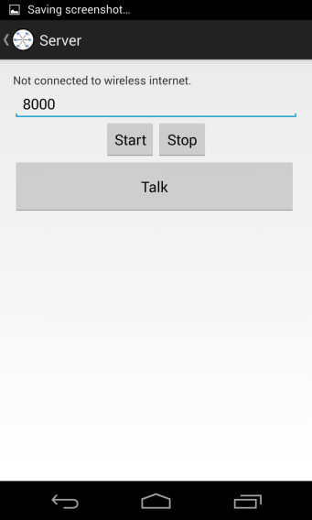

Figure 2c: Menu System with image buttons

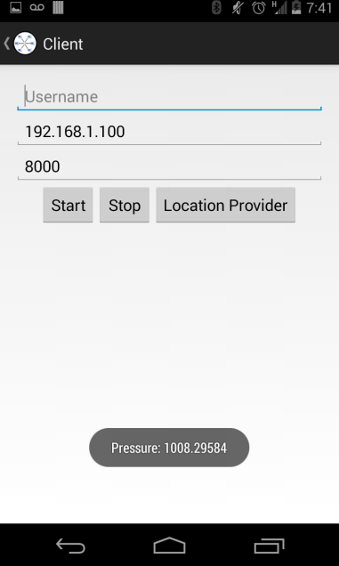

## Figure 3a: Generate Google Maps

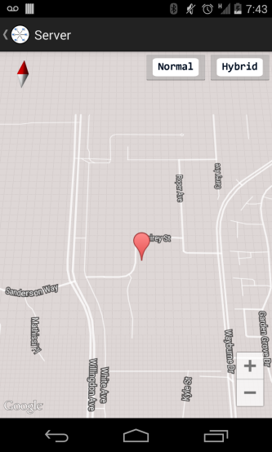

## Figure 3b: Generate Google Maps

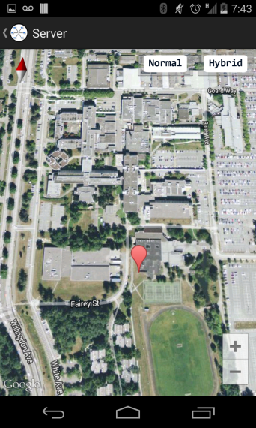

## Figure 4a: Get Barometric Data

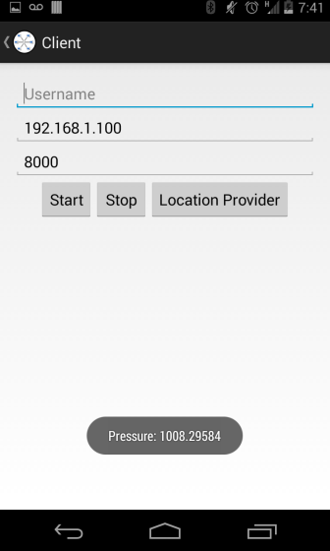

## Figure 4b: Get Barometric Data

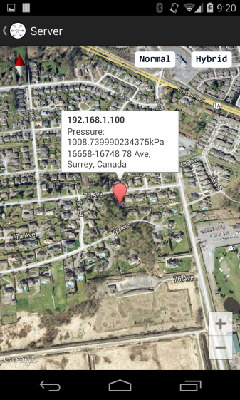

## Figure 5: Text to Speech Feature

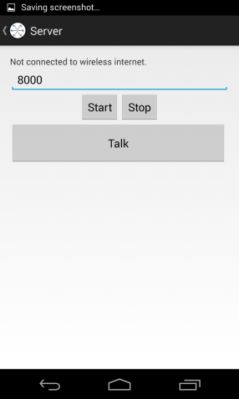

## Figure 6a: Tracking Client on Map

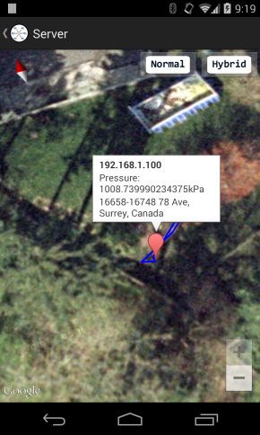

## Figure 6b: Tracking Client on Map

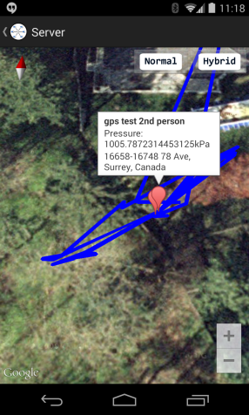

## Figure 7a: Changing Map Type

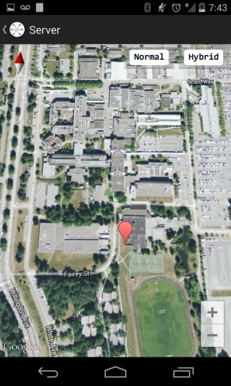

## Figure 7b: Changing Map Type

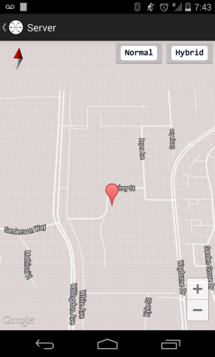

## Figure 8: Display Address-Coordinates

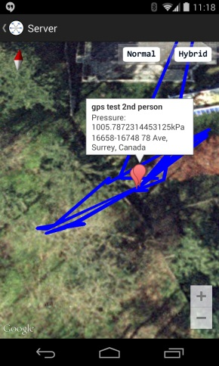

## Figure 8b: Display Address-Coordinates

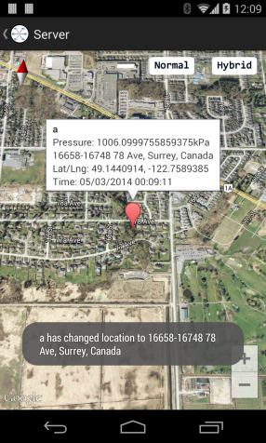

## Figure 9: Toast messages for TTS



## Figure 10a: Take a picture with the front camera

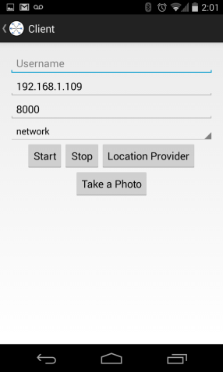

## Figure 10b: Take a picture with the front camera

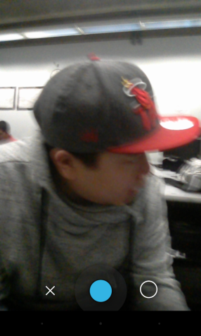

## Figure 10c: Take a picture with the front camera

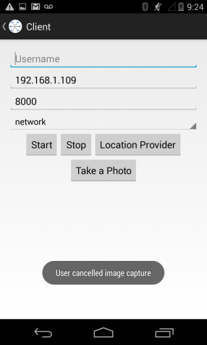

## Figure 10d: Take a picture with the front camera

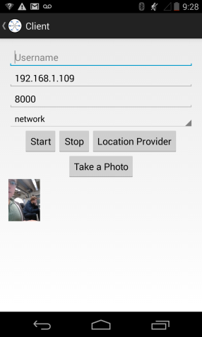

## Figure 11a: Send picture/Display on Google Maps



## Figure 11b: Send picture/Display on Google Maps

